Building Modeler Guide
Revision 2011-12-15 Joseph Lewis

Table of Contents
The Building Modeler Java Applet 3
Command Line Options 3
Getting Started With the GUI 4
Plotting 5
Tables 6
Editing The Database 6
Device Types 7
Buildings 8
Database Errors 9
Troubleshooting 9

The Building Modeler Java Applet

Command Line Options

usage: usage: java bmod <params>
-b,--building <arg> the name of the building to generate data for
-e,--end <arg> an ISO 8601 date string the program stops
generating data at
-i,--interval <arg> the interval to generate at in seconds [default:
60]
-o,--output <arg> the file to output data to
-s,--start <arg> an ISO 8601 date string the program starts
generating from: i.e. '1776-07-04 12:00:00'
-t,--threads <arg> the maximum number of threads to use for running
buildings, [default: number of cores you have]
When running BMOD from a command line, you must at least include the options b, e, o, s. Example:
bmod -b Olin -s “2011-10-11 00:00:00” -e “2011-11-11 00:00:00” -o tmp.csv
The Building indexed would be “Olin” and the program would start generating data for October 2011 through November 2011, and the output file would be in the same directory you launched the application from and named tmp.csv.
Lines in that file would contain all time intervals starting midnight on October 11th 2011 and would be incremented by 60 seconds each. This would be a relatively long operation as a months worth of data would be generated one minute at a time. To make this go faster you could use the -i flag, and set the number of seconds to something higher.
The number of threads used allow the machine to parallelize the generation of room data.
Starting the program from a command line will launch the graphical interface.

Getting Started With the GUI
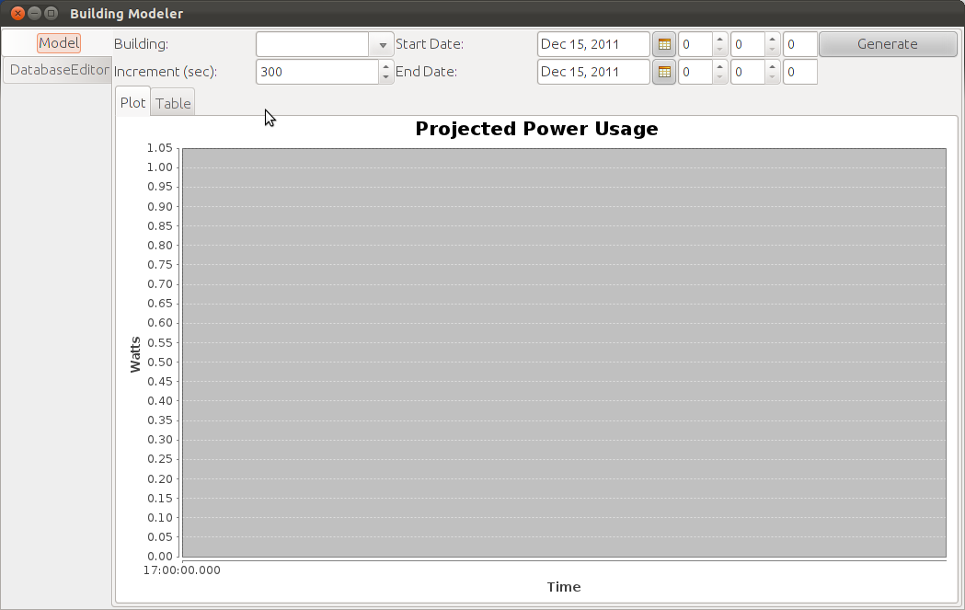Illustration 1: First Run
Upon opening the program for the first time, you will see an interface similar to the one above. The first time the program is run it may take a few extra seconds to show up as it generates the necessary database files.
The open tab is the “Model” tab, it allows you to generate tables and plots of projected power usages over specified intervals. To operate it use the Building picker to choose a building (the first time the program is run there will be no buildings), the start and end date pickers to choose the rough date, and the time pickers to set particular times of day if needed. By default the interval to generate data points at is five minutes.
When you press the button labeled “Generate” the program will generate the projected usage over the given time.
! | The program may appear to freeze if given a large date range. Try increasing the increment to get snappier results for larger ranges.

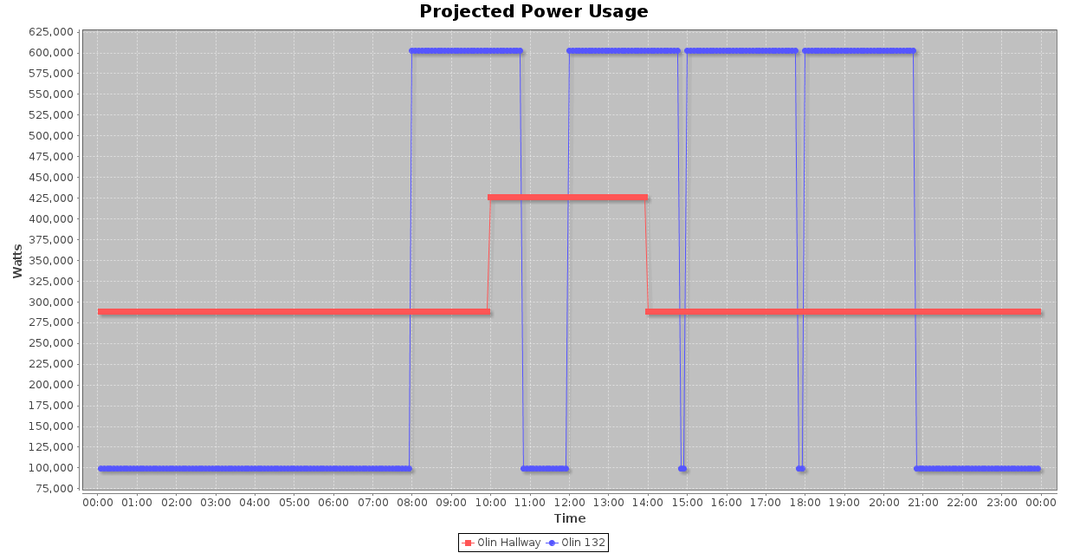Illustration 2: A Sample Plot
By default, rooms with no power consumption for the given time period will not be plotted.

Plotting
You may drag a box on a plot to zoom in to the selected area, to zoom back to defaults again, secondary click on the plot and use the context menu item “Auto Range” > “Both Axes”.
From the contextual menu you may also:
- Print the plot
- Save the plot as a PNG image
- Copy the image to the clipboard
- Set axis labels, title, and plot settings

Tables
If you wish to inspect the data more closely, you may do so under the “Table” tab at the top of the plot.
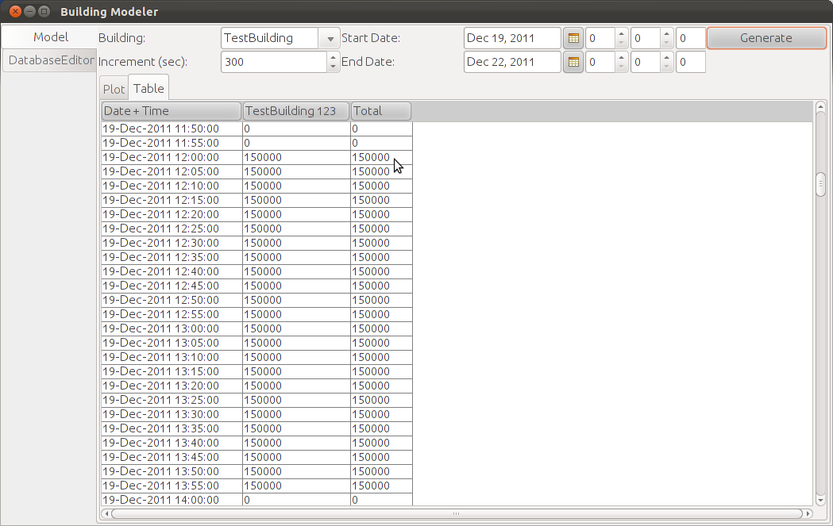
To sort columns, you can click on the column header, click again and they will be reverse-sorted.

To select rows, clicking on one, and dragging the mouse up or down to highlight more. To select all rows, use the keyboard shortcut Control + A. Once rows have been selected they can be copied to the clipboard by using Control + C and pasted in to a word processor or spreadsheet.

Editing The Database
The Building Modeler uses a database comprised of comma separated value tables placed in the “Database” folder located in the same folder that you launch the application from. These may be edited by hand, or edited through the easy to use “Database Editor” located below the “Model” tab on the left of the window.
When the program is started, it makes backups of all the database tables it loads, this way if a mistake is made, you may close the Modeler, and copy the relevant file with the extension “.bak” over the one with the original name.

− | Internally the Building Modeler uses a SQL database to work with the given data, it produces some files that you may see if you open the Database directory.

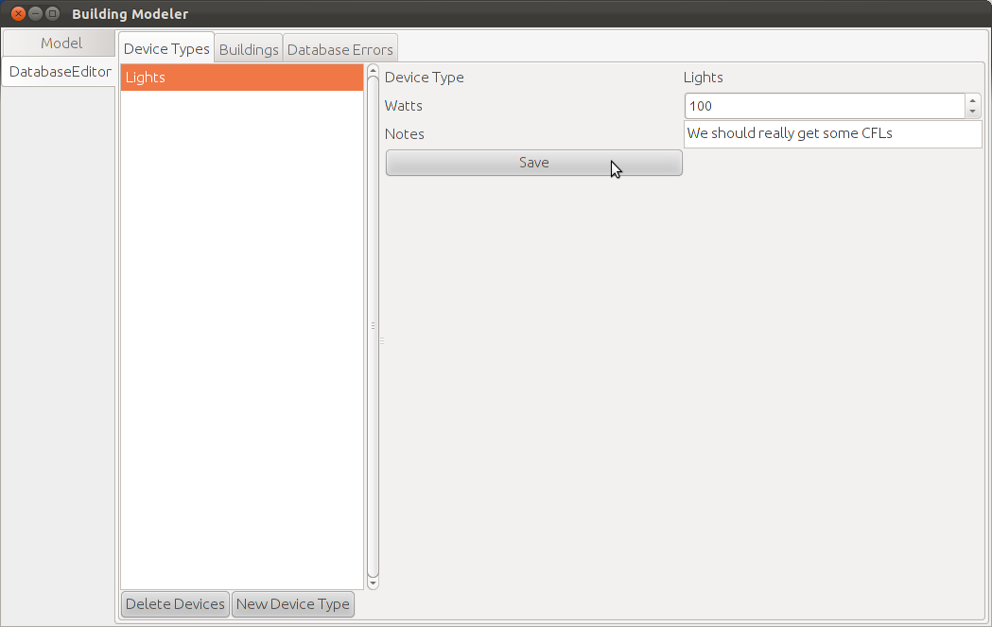Illustration 3: Device Types Editor
There are three tabs at the top of the Database Editor tab, these are “Device Types”, “Buildings”, and “Database Errors”.

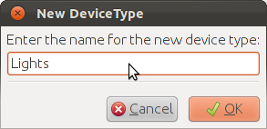
Device Types
Device Types allows editing of generic devices, such as lights. Once a device is chosen from the chooser on the left, an editor will show up on the right, after editing, press the “Save” button and your changes will be saved to the database. New devices can be added with the “New Device Type” button below the device chooser; once pressed a new entry box will appear and request the name for the new device, if a name is entered it will show up in the chooser.
To delete devices you may select as many as you like from the chooser using a Shift + Click to select multiple contiguous rows, or a Control + Click to add a row by itself, then by pressing the “Delete Devices” button at the bottom of the chooser. You will be prompted to delete the rows, after which they will be removed.

Buildings
The building editor operates in much the same was as the Device Type editor, buildings may be chosen, created, and deleted on the left-hand side of the panel. On the right side there are two more tabs, the Activity and Load editors.
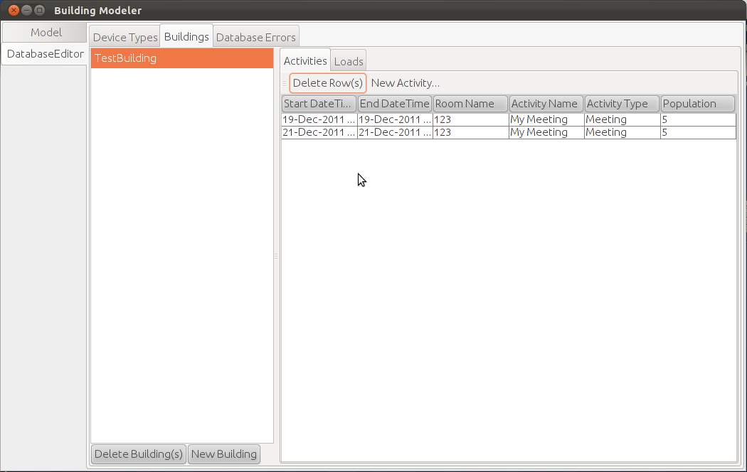Illustration 4: Building Activities Editor
Activities
Rows can be selected and deleted in the same way that buildings are. New activities can be generated using the “New Activity” button on the toolbar, located next to the “Delete Row(s)” button. This button will bring up a dialog box that will assist in generating as many activities as required.
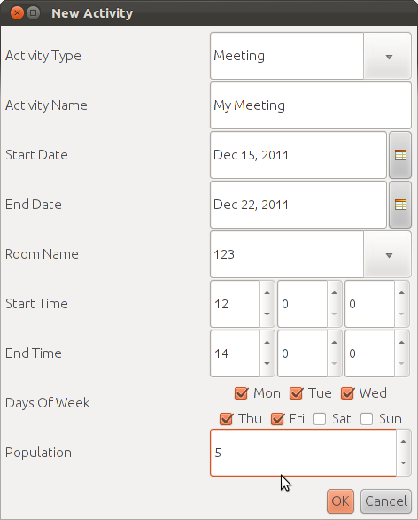
From this box you may choose or enter a new activity type, the name for the activity, the start and end dates, and times for which the activity will occur. Note that the end date should be the day after which the last activity occurs. Also note that activities may not cross date boundaries, in order to accomplish this create two activities, one from the start time to 23:59:59 and the other from 00:00:00 to the end time.
Once “OK” is pressed activities will be generated for every day of the week that is chosen between the start and end date.
Note that the program may pause while generating many events.
Loads
Loads may be edited through the “Loads” tab, located next to the “Activities” tab. They operate in the same manner as the device types editor.

Database Errors
This tab is largely open for future development, it currently displays non-critical errors that the program encounters while generating a model. These may help discover why models are not turning out as expected.

Troubleshooting
Problem | Solution
The program shows an error while starting. | If the program crashed last time, it is possible there is a database problem, fix it by entering the Database directory and deleting the files “bmod.lck” “bmod.script” “bmod.log” and “bmod.properties”  If none of those files exist, make sure you have write permission on the directory you launch the program from.
The program won't start | It is likely that you either have a program running already, or one failed to shutdown properly. Try opening your task manager and killing the Java process that started the program if it is running; afterwards delete the “bmod.lck” file in the Database directory.
Other problems | Contact me at joe@josephlewis.net.

